**PROJECT DEVELOPMENT DELIVERY OF SPRINT-2**

|  |  |
| --- | --- |
| TEAM ID | PNT2022TMID31693 |
| PROJECT NAME | SMART SOLUTIONS FOR RAILWAYS |

Proposed architecture for smart track monitoring system.

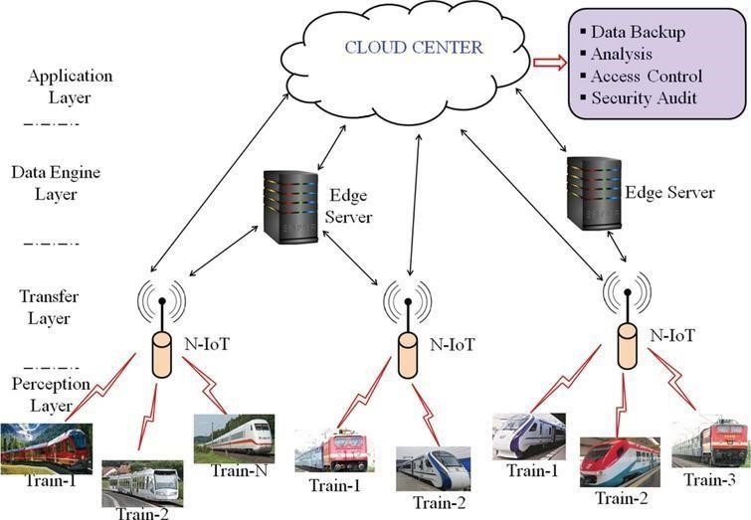

Structural health monitoring of railway tracks using IOT-based multi robot system:

